S11_2420030739_Experiment 2_Case Study
Problem Statement: Identify an appropriate case study and select a suitable process model and programming language for its implementation and evaluation.
1. Functional Requirements
Customer
- Register and login
- Record voice using microphone
- Select a preferred language or auto-delete
- Convert speech into text
- View transcription results instantly
- View transcription history
- Search previous history
- Filter transcription history by language
- Delete language
- Switch between dark mode and light mode
Admin
- Manage groq API configuration
- Manage MongoDB database connection
- Monitor storage capacity
- Maintain transcription records
- Ensure backend security and data integrity

2. User Stories
User ID | User Story | Priority
US-01 | As a user, I want to record my voice using the microphone so that I can convert speech to text | High
US-02 | As a user, I want to choose my preferred language before recording | High
US-03 | As a user, I want the system to delete my language automatically | Medium
US-04 | As a user, I want to search my transcription history | Medium
US-05 | As a user, I want to delete unwanted transcription records | High
3. Selected Software Development Process Model
Agile Scrum
Reason for Selection
• Requirements change frequently.
Allows continuous feedback
- Flexible for adding future features
- Supports rapid development
Sprint Plan
Sprint | Features
Sprint 1 | User Registration & Login
Sprint 2 | Record voice and task
Sprint 3 | Convert sppech-to-text
Sprint 4 | Can see transcription history
Sprint 5 | Testing &deployment

4. Programming Language Selection
Backend
- Java (node.js)
- Express.js
Reasons
- Fast and light weght
- Easy REST API development
- Efficient asynchronous processing
- Full stack Java script development
Frontend
- HTML.5
- CSS3
- JavaScript
- React.js
- Tail wind css

Database
:MongoDB
Other Technologies
- Groq whishperAPI
- Multers
- Rest API
- Vesel
- Render
5. System Architecture
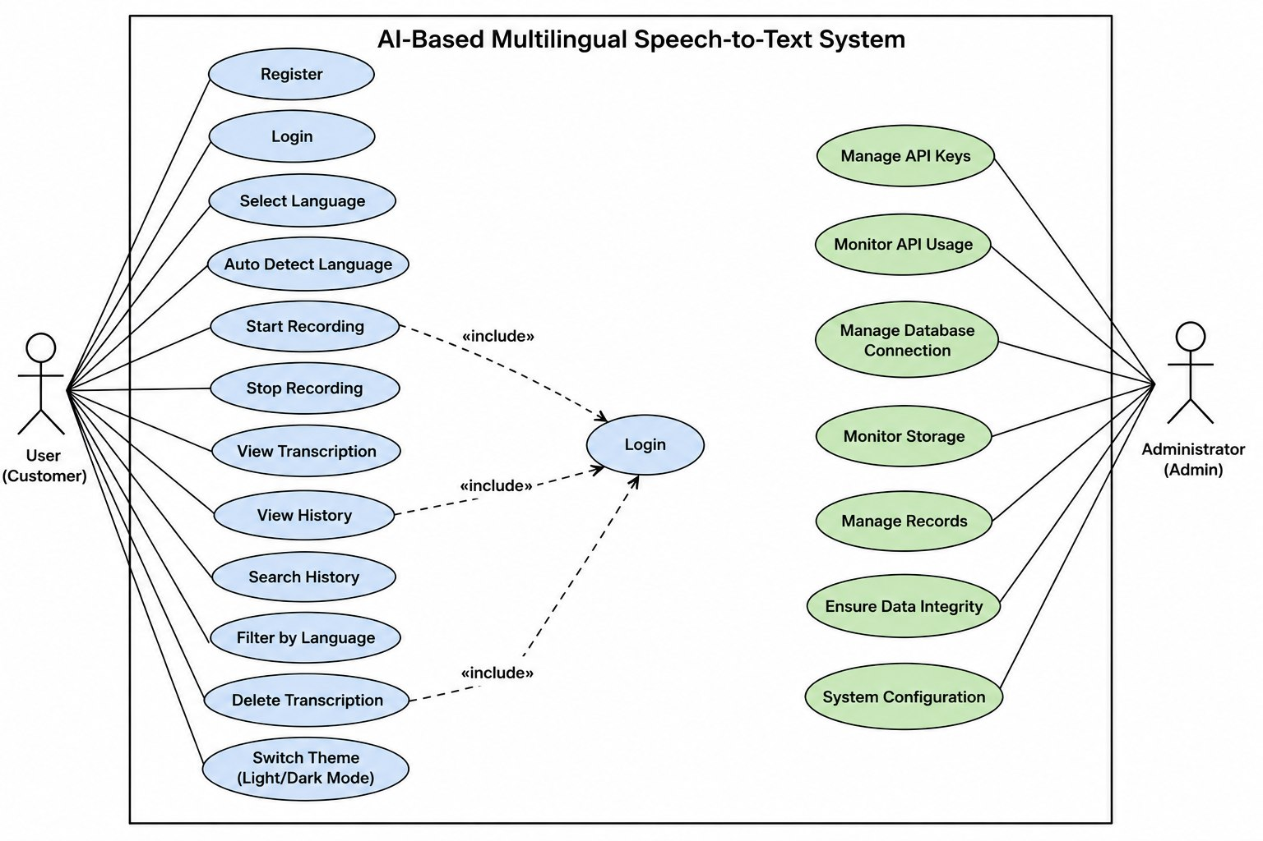

6. Implementation Strategy
Phase 1 – Requirement Analysis
- Gather user requirements
- Prepare SRS

Phase 2 – System Design
- Design mongoDB schema.
- Design UI wireframes.
- Define REST API
Phase 3 – Development
- Implement audio recording
- Integrate Groq whisper API
- Develop transcription history
- Add, delete operations
Phase 4 – Testing
Unit Testing
- Login
- Audio recording
- Language selection
- Theme switching
Integration Testing
- Frontend + backend
- Backend + mongo DB
- Backend + groq API
System Testing
- Complete application testing
User Acceptance Testing (UAT)
- Verify business requirements.

Phase 5 – Deployment
- Frontend using vessel
- Backend using render
- MongoDB atlas database

7. Evaluation Strategy
Evaluation Parameter | Method
Functional Accuracy | Requirement verification
Performance | Fast multi lingual speech-to-text conversion
Security | Accurate real-time transcription
Reliability | Dark and Light mode support
Usability | High-performance AI-powered speech recognition.
Scalability | Responsive and modern user interface

10. Expected Outcomes
- Dark and light mock support high performance AI-powered speech, recognisation
- Fast multi lingual speech to text conversion
- Accurate real-time transcription
- Secure backend architecture

Name: CH.LUCKY REDDY
Roll no: 2420030739
Section: 11

